facebook.com/nilesuk @alexfoster nilesuk@gmail.com +44 7967 025 604
www.alexfoster.me.uk 21 Dornoch Avenue, Nottingham, NG5 4DQ
NILESLETTER 2015
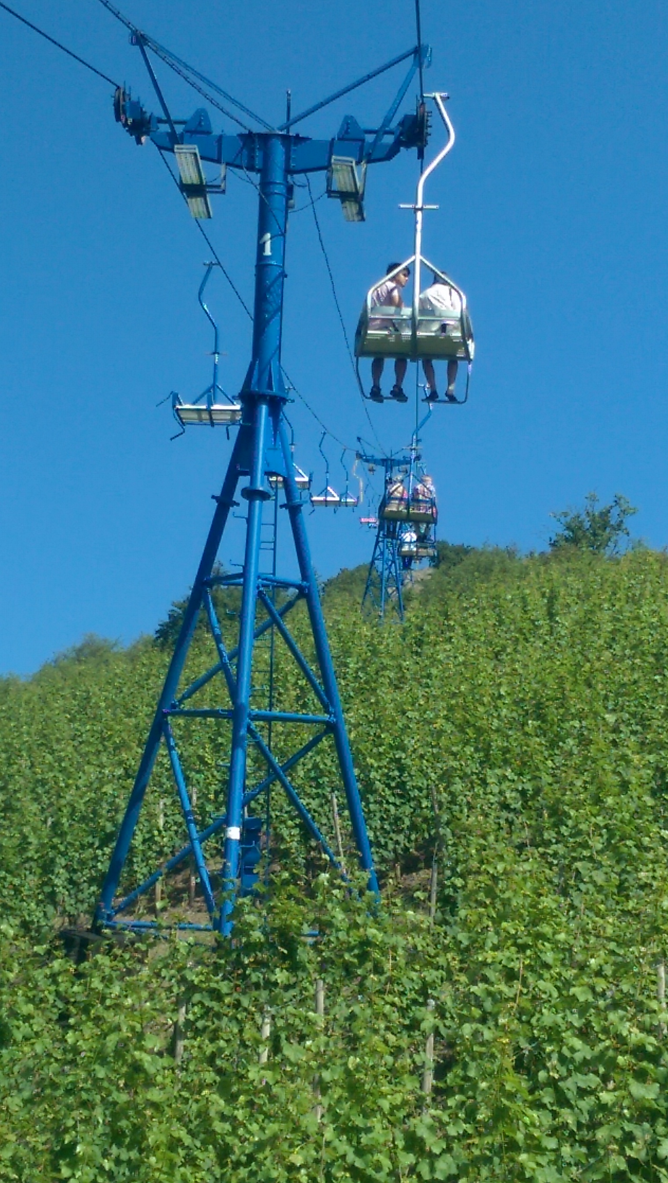2015 has been a tricky year and next year will bring its challenges too.
Firstly my mother’s longstanding blood disease took a turn for the worse, turning into full blown leukaemia. She underwent a bone marrow transplant over Easter but we heard in November that this had not been successful. She was given a series of options but all were unpleasant, invasive and involved a lot of travel, and the best of them did not offer much hope in terms of longer life, so she has chosen not to take them. Both she and my father are impressing us all with their pragmatism and stoicism, since this is likely to be her last Christmas.
In February, after thirteen years together and nearly five in a civil partnership, Paul asked for a divorce. The year has been spent in separating our finances and chattels; in September he moved out and by January next year the paperwork will be complete. I kept the house and the animals. He has moved into a flat in Carlton – let me know if you need his new address. I now live alone for the first time in my life which has its rewards and challenges. We will be staying in touch and remaining friends.
Finally, work has been massively challenging this year too. An Ofsted “requires improvement” grade has put us all under a lot of pressure and increased everyone’s workload and accountability. As I write we are due another monitoring visit next week. In the almost complete absence of a work/life balance, some weeks the best I have been able to work on has been a better work/sleep balance.
In the spirit of keeping myself busy I have been away as often as I can and rejoined some of my old social groups. I have even had multiple weekends away in term time, which have been hugely enjoyable, but the jury is still out on whether the enjoyment balances the exhaustion. I have camped in Derbyshire and Kent, been to a youth hostel on the North York Moors, and taken part in ringing weekends in Pembrokeshire and Shropshire. February was amazing - I had a super week at St Bride’s Castle over half term and also took a huge group of friends to Cavendish Hall with the Landmark Trust for a weekend of pretending we lived in a stately home.
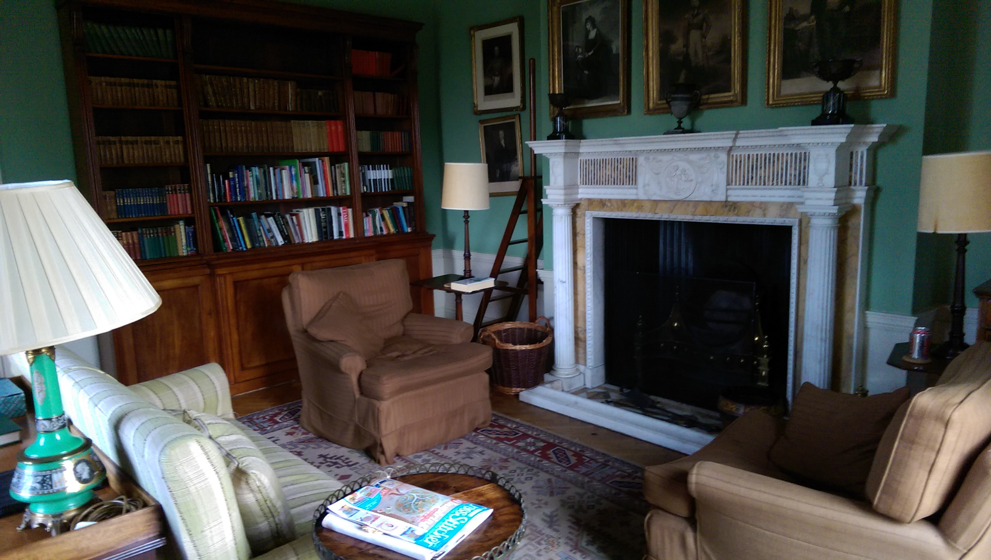
Figure 1 The library at Cavendish Hall
Easter P and I went to Brussels together (booked before divorce discussions) Over the summer I sang in Bude and at Exeter 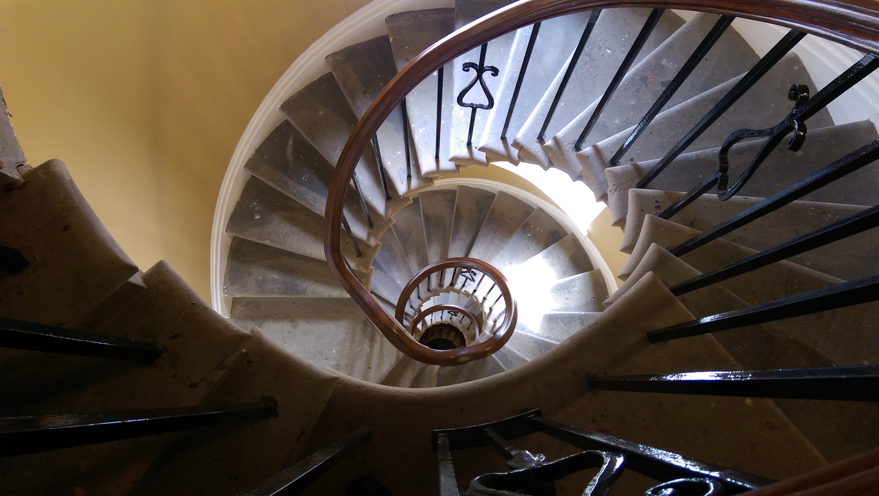
Figure 2 The back stairs at St Brides Castle
Cathedral and took a party of 40 12-year-olds to the Rheinland. Sadly this December’s Paris trip was postponed for understandable reasons.
Next year will likely see me in the Rheinland again in July, and in Hereford in August. I’ll also be in Glencoe in a kilt for Hogmanay!

